RCS Daily Operations

Table of Contents

Objective 2

1. Postman 2

Ticket Creation 2

Fetch Emails to RCS Tickets 2

Redirect Emails to Internal Teams 2

Assign Emails to Internal Teams 3

Customer Escalation 3

2. Ticket Handling 4

MSS Request Ticket 4

Incident Ticket 4

Escalation to Upper team 4

Handover 5

3. Ticket Follow-up 5

Appendix. MNOC Operation 6

Postman/Ticket Handling 6

# Objective

The objective of this document is to delineate the operational scope of RCS team and provide guidance to team members. Additionally, it aims to foster effective collaboration and coherence among various teams involved, mitigate confusion, and optimize collective efforts towards our team goals.

# Postman

## Ticket Creation

Monitor RCS postman (formerly SD postman) and create new tickets for unassigned emails under RCS resource by default. Teams can use filter “Unread without ticket” to filter out such emails.

The personal who creates the ticket shall initiate the first response to inform the customer about the ticket creation and then work on the case.

Some customers are labelled as VIP, and their emails are highlighted per below. We should process their emails first, when we see them.

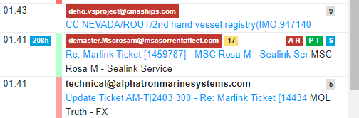

## Fetch Emails to RCS Tickets

Monitor RCS postman and fetch emails to existing RCS tickets. Colour code: pink

## Redirect Emails to Internal Teams

If an email is addressed to another internal team, and they are not in the email loop, we can forward to them by below:

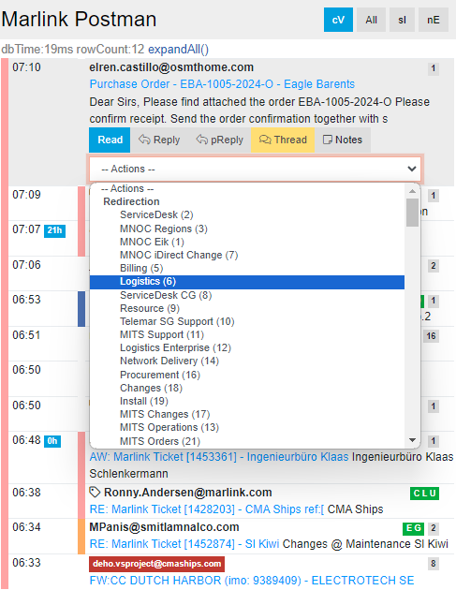

## Assign Emails to Internal Teams

If the ticket is already assigned to another team, e.g., MNOC Bratislava, CCTS etc., we should assign the email to them.

Note: the difference between Redirection and Assign is:

Redirection= forwarding an email to an email address, e.g., [resource@marlink.com](mailto:resource@marlink.com)

Assign= assign an email to a resource, who shares the same service desk email with RCS, e.g., MNOC Bratislava and CCTS

Note: we still work on MNOC Bratislava tickets as of now.

## Customer Escalation

Email to [escalation@marlink.com](mailto:escalation@marlink.com) is automatically forwarded to RCS postman, as example below. RCS team shall acknowledge on the reception to customer, and forward it to the relevant team. Depending on the case’s severity, RCS may call relevant team on their on-call.

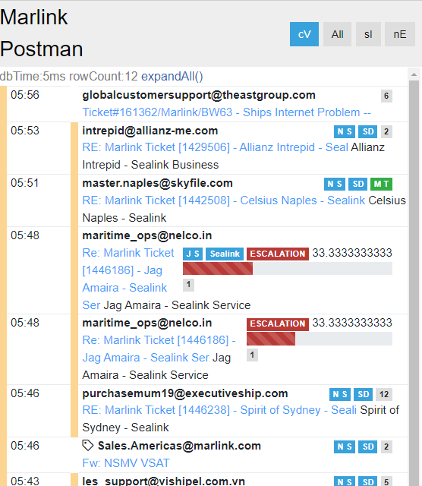

# Ticket Handling

VSAT 8 should work on the tickets on the dashboard [here](https://merits.marlink.com/tss/product/tticket/management/default.cfm?page=2&resourceid=41&cmbSort=9&chkSeverity=5,4,1,2&chkSLA=4,3,2,1&txtRefreshRate=300&radioStatus=StatusOpen&cmbCategory=&salesRegion=&cmbSubCategory=&cmbProblemStatus=1&chkSubtask=1&chkUnknownDd=0&chkDeliveryRush=0&cmbCustomer=&cmbInstallationSystem=&cmbSite=&cmbAssignedTo=0&cmbRCSCenter=). They are sorted in the order to aTTU, or “Ticket Action ASC”, with below filters applied:

* Assigned: “unassigned”
* RCS center: “All”

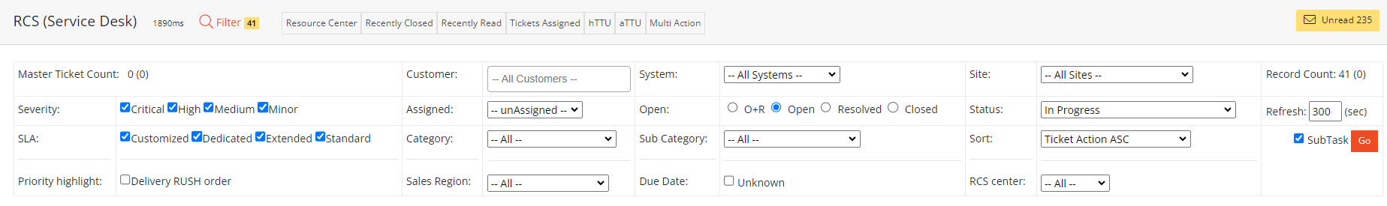

We should treat premier and elite customers’ ticket with priority. Examples below:





Tickets status must be updated afterwards, e.g., to “waiting for customer”. We should set “auto close” when there is a good chance that customer may not reply to us, e.g., after a beam switching and blockage check.

Key findings in troubleshooting should be captured in ticket notes.

## MSS Request Ticket

RCS should validate that customer has provided the necessary information for activation and deactivation tasks, then forward the ticket to Backoffice team.

You can refer to our flowcharts:

* Sat-C: <https://miro.com/app/board/uXjVNmgHHwc=/>

## Incident Ticket

RCS should follow the scope as defined in [Excel matrix](https://mobsat-my.sharepoint.com/personal/erik_holtrin_marlink_com/Documents/Alpha%20project/Job%20Description%20MNOC%20247.xlsx?web=1), and fulfil the minimum work required before escalating to MNOC Bratislava.​

## 

## Escalation to Upper team

Ticket should be passed to upper team, if it is not within RCS scope. We should inform customer about the escalation, to keep them updated.

## Handover

Before the end of their shift, team shall handover ongoing tickets to other teams in RCS group chat. The ticket status should be set to Handover too per below screenshot.

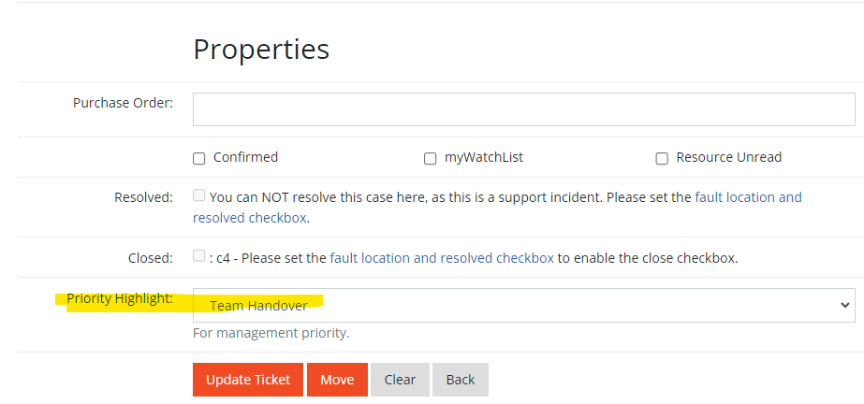

# Ticket Follow-up

We should follow up on the open tickets under our region, dashboard link [here](https://merits.marlink.com/tss/product/tticket/management/default.cfm?page=11&resourceid=&resourceall=1&cmbSort=&chkSeverity=5,4,1,2&chkSLA=4,3,2,1&txtRefreshRate=300&radioStatus=StatusOpen&cmbCategory=1,3&salesRegion=&cmbSubCategory=&cmbProblemStatus=&chkSubtask=1&chkUnknownDd=0&chkDeliveryRush=0&cmbCustomer=&cmbInstallationSystem=&cmbSite=&cmbAssignedTo=0&cmbRCSCenter=4).

Filters to be applied: RCS center, “incident” “Request” category, ALL resource, “In progress” status, Unassigned.

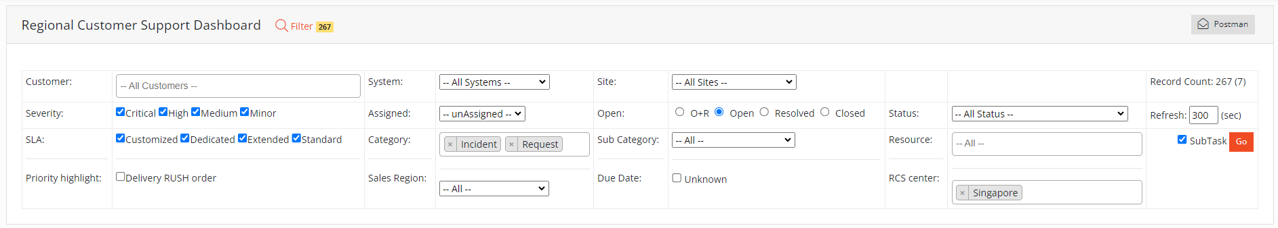

# Appendix. MNOC Operation

During the transition period, SG and US RCS teams will continue to function as rMNOC, outside MNOC Bratislava’s working hours. This is to be reviewed by 3rd June, when Bratislava is expected to work 24x7.

## Postman/Ticket Handling

Select “MNOC Regions VSAT Support” filter in postman, and work on the emails on first-in-first-out basis.

